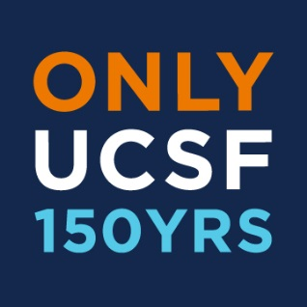

Alumni Association of UCSF
Board of Directors
Tuesday, September 16, 2014
Faculty Alumni House, 745 Parnassus Avenue, San Francisco, CA
5:30pm – 7:25pm PST

5:30pm – 5:50pm Dinner

5:50pm – 5:55pm Welcome Susan Walczak, President

5:55pm – 6:15pm Guest Speaker Carrie Steere-Salazar
Director, Student Financial Aid
Student Academic Affairs

6:15pm – 6:25pm Guest Speaker Matthew Cummings
President of the Graduate and Professional Student Association (GPSA)

6:25pm – 6:35pm 150th Anniversary Alumni Excellence Awards Susan Walczak, President
Andrew Kaufteil

6:35pm – 6:50pm Committee Reports – (~3 minutes each)
- 6:35pm – 6:38pm Alumni Weekend: Shawn Houghtaling
- 6:39pm – 6:42pm Alumni-Student Engagement: Todd Golden
- 6:43pm – 6:46pm Diversity & Outreach: Biana Roykh
- 6:47pm – 6:50pm Advocacy: Debra Vails-Qualters

6:50pm – 7:00pm AAUCSF document archive website Dan Keller, Treasurer
Budget & Revenue
Approve Minutes
Financials and minutes included in packet.

7:00pm – 7:20pm Overview of Board Members John Skhal, Nominations Chair
and School Alumni Representatives

7:20pm – 7:25pm New Items Andrew Kaufteil

7:25pm Meeting Adjourned

2014/15 remaining meeting dates:
December 2, 2014
March 10, 2015
June 23, 2015

